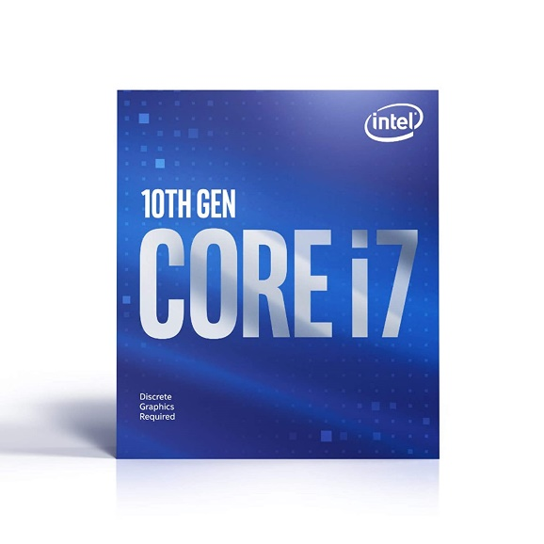

Inner

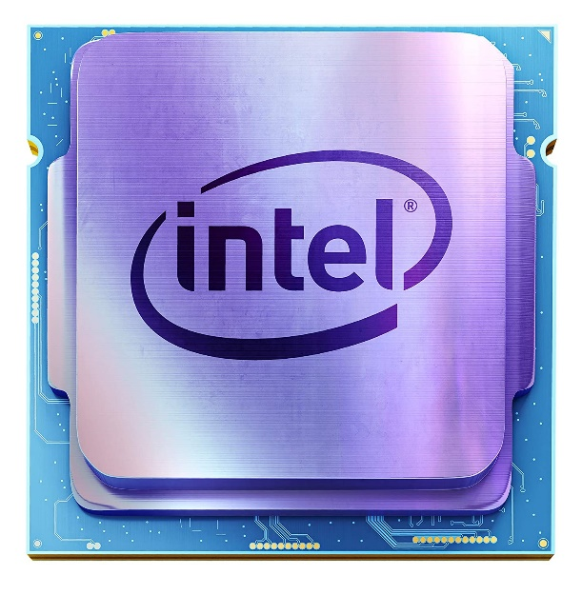

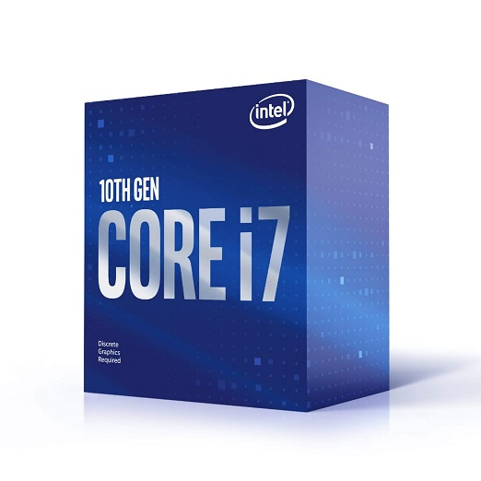

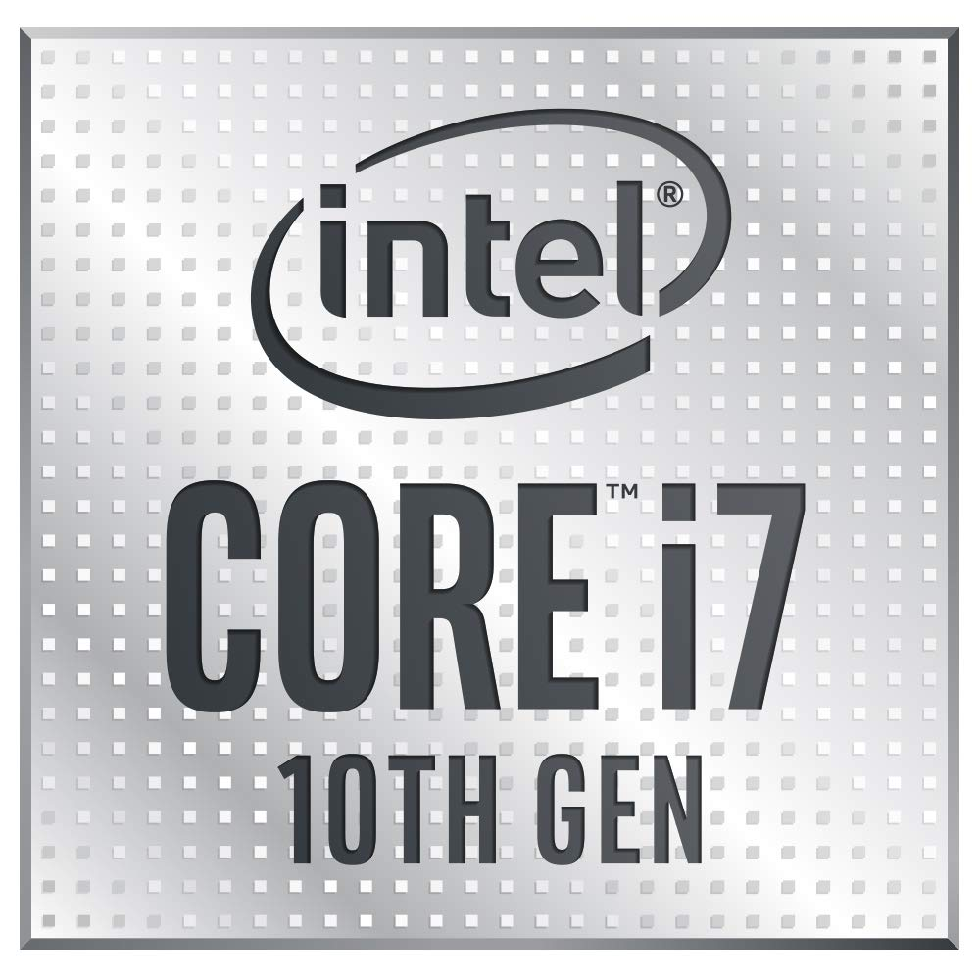

Intel® Core™ i7-10700F Desktop Processor 16M Cache, up to 4.80 GHz LGA1200

-49% ₹22,500.00

M.R.P.: ₹44,+000.00

|  |  |
| --- | --- |
| Brand | Intel |
| CPU Manufacturer | Intel |
| CPU Speed | 4.8 GHz |
| Platform | Windows |
| Wattage | 65 Watts |

**About this item**

* Up to 4. 8 GHz
* 8 Cores / 16 Threads
* Socket Type LGA 1200
* Intel Optane Memory Support
* Compatible with Intel 400 series chipset based motherboards
* Intel Turbo Boost Max Technology 3. 0 Support
* Cooler Included